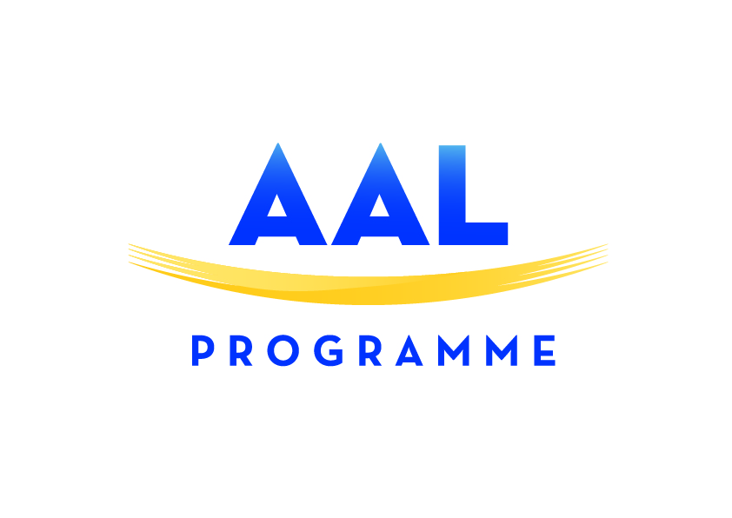
Project Fact Sheet

Recommendations on how to fill in this project presentation

Speak plainly
Write this document as if you had to explain your project to a four-year-old child! Simplicity and clarity first.
Use a language that a very large audience will understand. And bear in mind that even the editor/journalist himself may not be a specialist in your particular field, so avoid unnecessary scientific jargon.
Illustrations
Yes, one image tells more than one thousand words. So please avoid images of complex and hardly understandable schemes or architecture. The document should be illustrated with 2 photographs/illustrations with a resolution of at least 300 dots/inch (dpi), which normally means a file size of more than 1 MB per picture.

Size of the document
Respect the limits set in the following fields.
Name of the project and acronym

Coordinator (Name of the company or organization):

Duration (in months) of the project and starting date (month, year):

Consortium:

Objective of the project (Get inspired with the questions below in 7 lines sharp):
Please specify clearly what your project will deliver or address in a concise, yet exhaustive manner.
Reply to questions like:
Why does this project exist?
What is the problem or unmet need that it tackles?

Project Overview (Including technology in use, end-users involvement – 12 lines sharp):
Please do not copy and paste the same description that you used for the call application. This will be read by a wider audience of people who may know little about the ageing society, technology and rocket science…

Review the background and technological rationale for undertaking the initiative
Explain the provisions being made for education, knowledge-sharing and exploitation of the findings

Expected results and impact (Get inspired by the questions below in 7 lines sharp):
- Quantify the results
- The (data, value) should be compared with measures used in everyday life
- Estimation of the time necessary to reach the market
- Where do you think you will be at the end of the project?
Business ideas?
- Social aspects that you will have solved, addressed, tackled?
- Individual needs that you think you will help to fulfil?
- Etc…

Total budget of the project:
Format e.g. 2,2 mi €

Public Contribution (National + EC):
Format e.g. 1,2 mi €

Images or graphic (Logo, images or photos showing the product or service):
Images or photographs (also graphics where needed) are mandatory. Send jpg or esp file. In the case the images suggested do not meet the explanatory ends or do not have the right resolution, we reserve the right to use other sources. Be reassured though, the final editing will be shown to you before going to the printing
Website link(s):
IMPORTANT!!!
Contact person (name, e-mail, and phone):

Moreover, we ask you to indicate a maximum of 6 tags that, in your opinion, can represent your project from this drop down list. (Note that all the tags exceeding 6 will be not be taken into consideration)

DOUBLE CLICK ON THE TABLE TO CHOOSE FROM THE MENU

